REPORT OF EVENT BOOKING SYSTEM

A website platform that connects the Internet and the real world

1. Requirement Specification:

1.1 User Stories:

2. Design and Implementation:

2.1. Interface decision and explanation:

2.1.1. Index Page

2.1.2. Login Form

2.1.3. Registration Form

2.1.4. Participant's Pages

2.1.5. Host's Pages

2.2. Implementation Information:

3. Test Plan:

4,MoSCoW Prioritisation chart

5,Risk Assessment

6, Data Flow Diagram

7, Github

8,Gantt chart

# Requirement Specification:

Decision Table: Log in screen

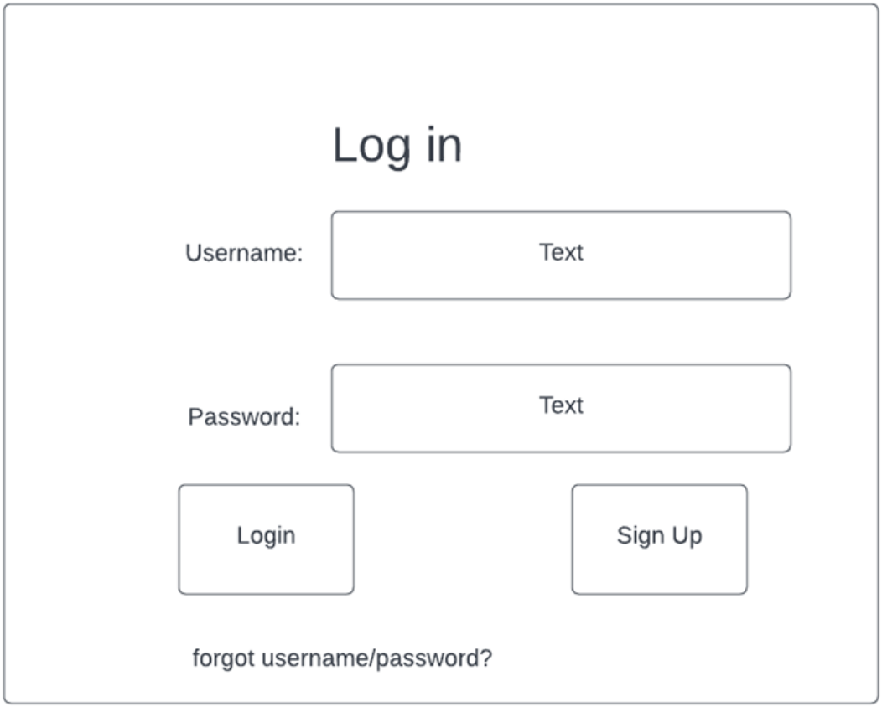

1, The Username and Password entered by the user are constrained to the following conditions.

1.1, The user is only allowed to Log In to view the home screen when entered a correct Username and password combination.

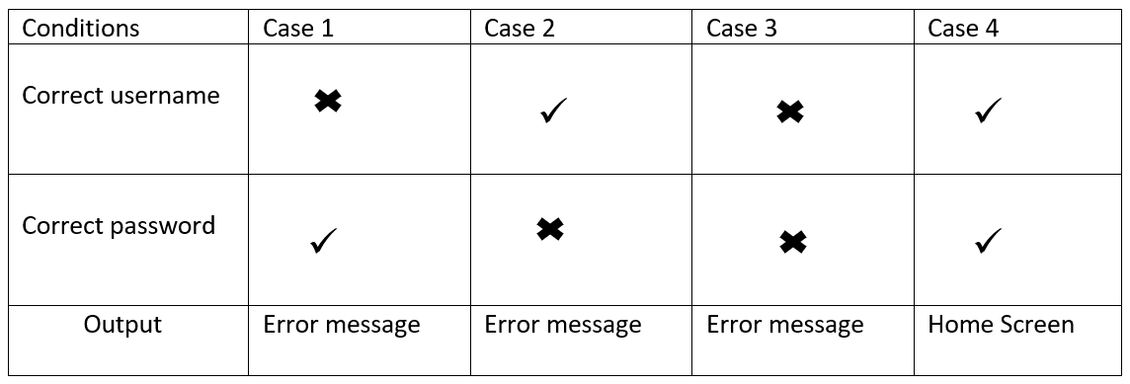

Case 1. If the user entered a wrong username but correct password, an error message will be displayed.

Case 2, If the user entered a correct username but wrong password, an error message will be displayed.

Case 3, If the user entered a wrong username and wrong password, an error message will be displayed.

Case 4, If the user entered a correct username and correct password, the home screen will be displayed.

## 1.1 User Stories:

1.1.1 As a user I need to register to Megabook website so that I can view and book upcoming events.

Acceptance Criteria:

The acceptance criteria for a user to register to Megabook are as follows.

1, User should have access to the internet.

2, User should have a valid email address.

3. User can register to Megabook with this information and book events.

User Stories:

1.1.2

As a registered user I need to search and select an event in Megabook website so that I can pay and attend the event.

Acceptance Criteria:

The acceptance criteria for a user to search and book an event in Megabook website are as follows.

1, User should have access to the internet.

2, User should have a valid email address.

3, User should have registered and verified their email id.

4. User should be able to login with their registered credentials (email id and password).

5, User should be able to search for an event.

6, User should be able to select the event they are intended to attend.

7, User should be able to pay for the event they selected.

8, User should be able to receive confirmation of the booking.

1.1.3

As a host I need to register and login to the Megabook website so that I can advertise the event I am promoting.

Acceptance Criteria:

The acceptance criteria for the host to register and advertise the events are as follows.

1, Host should have access to the internet.

2. Host should have a valid email address.

3, Host should register as a host.

4, Host will be able to advertise events after registration.

1.1.4

As a user I need to log in to the Megabook website if I forget my password so that I can book the events.

Acceptance Criteria:

The acceptance criteria for the user to reset the password as follows.

1,The user should have access to the internet.

2, The user should have registered and verified the email id with the Megabook website.

3, The user should select the forgot password option from the main screen.

4, The user should enter the registered email id.

5, The user then receives a link to reset the password.

# Design and Implementation:

## Interface decision and explanation:

### Index Page

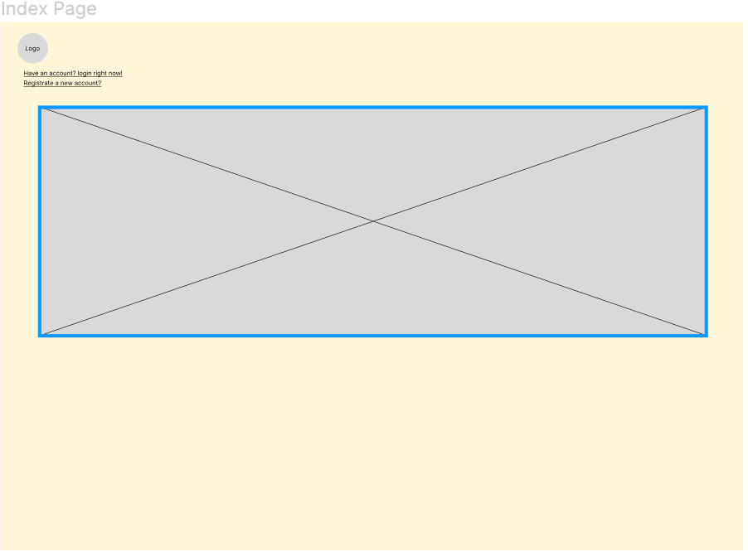

The first step to enter the event booking system is to come to the index page. On this page, the latest information and preferential information of various events released by hosts are presented repeatedly in the form of cutscenes. After that, the events that are currently followed by the most people will be displayed and you can click on the picture to enter the event page for more details. On the other hand, this page also provides two links to the login page and the registration page respectively.

### Login Form

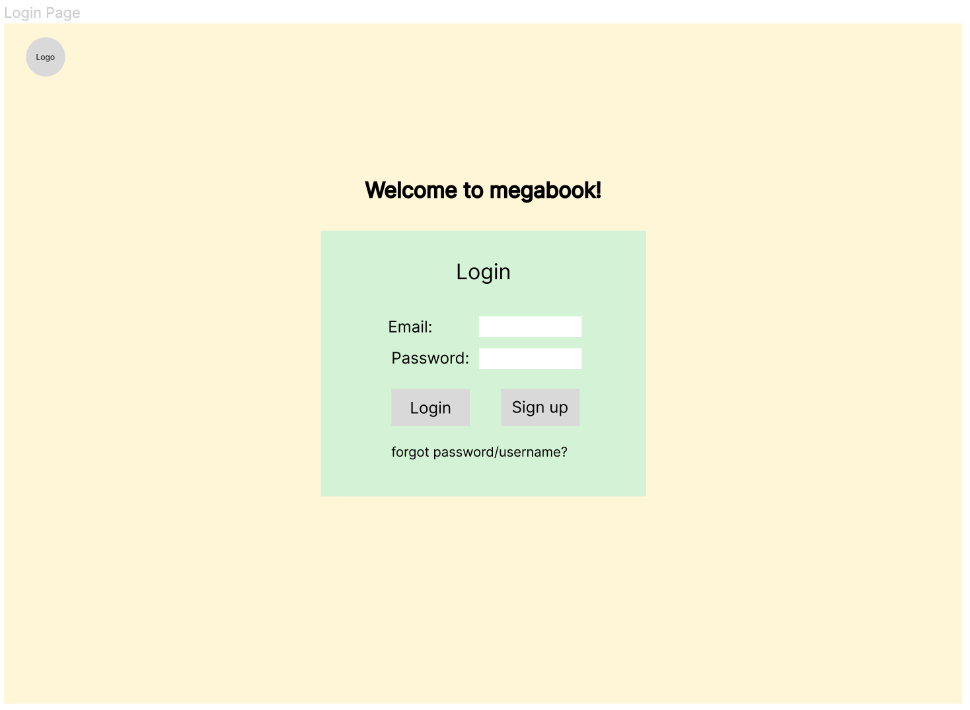

There are two input boxes on the login interface, respectively prompting the user to enter the email and password that have been registered and verified. At the email box, the user cannot enter special characters that do not comply with the email rules, such as "!" or "#", etc. As for the password part, all entered strings will be hidden first. When the user presses the login button, there are two events happening.

The user is only allowed to try the same mailbox up to three times. So the count will be minus one. After the third time, the server will record the device's Response Header such as user-agent, cookie, etc., and information of IP and prohibit the attempt for a period of time.

Apart from login, the user may need to go to the relevant page to retrieve the email or password through the forgot button.

### Registration Form

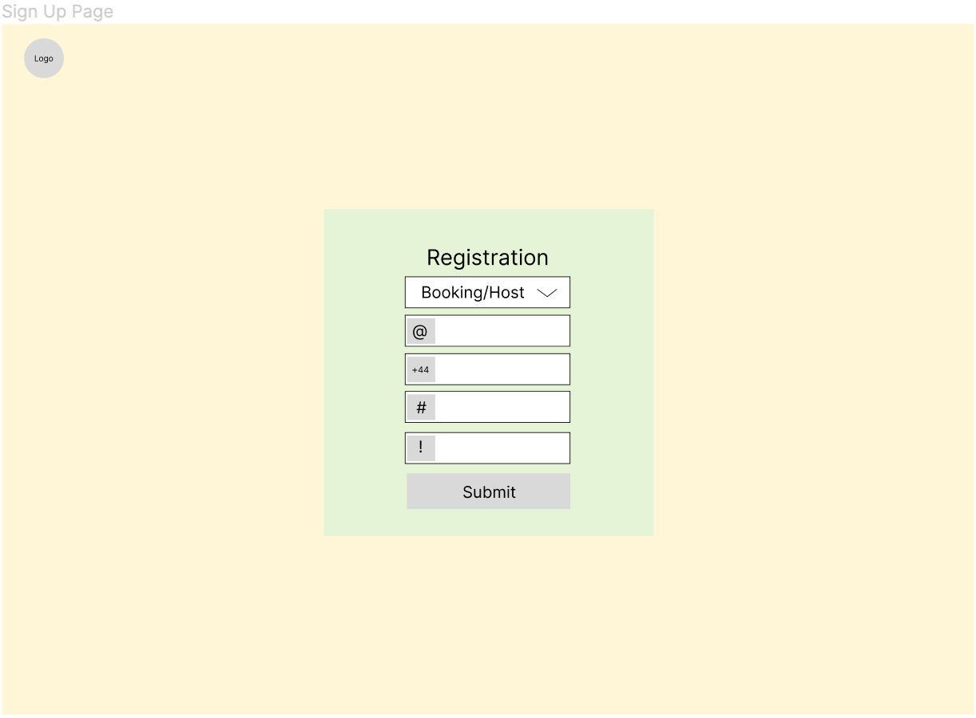

Visitors can choose to become participant users or host users through the drawdown list, both of which will have different identification records in the database. In addition, they can register accounts by filling in personal details such as name, email, phone number, etc. The account entered by the user will be directly stored in the database. All user details are not allowed to be disseminated to a third party without the permission of the user in order to protect users' privacy. According to an article on the privacy of Internet users,"a PC world survey (2003) of 1500 Internet users found that 88% were concerned about websites sharing their email address, and 91% were concerned about being tracked while using the web; Statistics Canada (2006) reported that 57% were wary of using credit cards online"(E. Motta, 2007). This shows the importance of privacy for users. Megabook will take them as a first principle.

### Participant's Pages

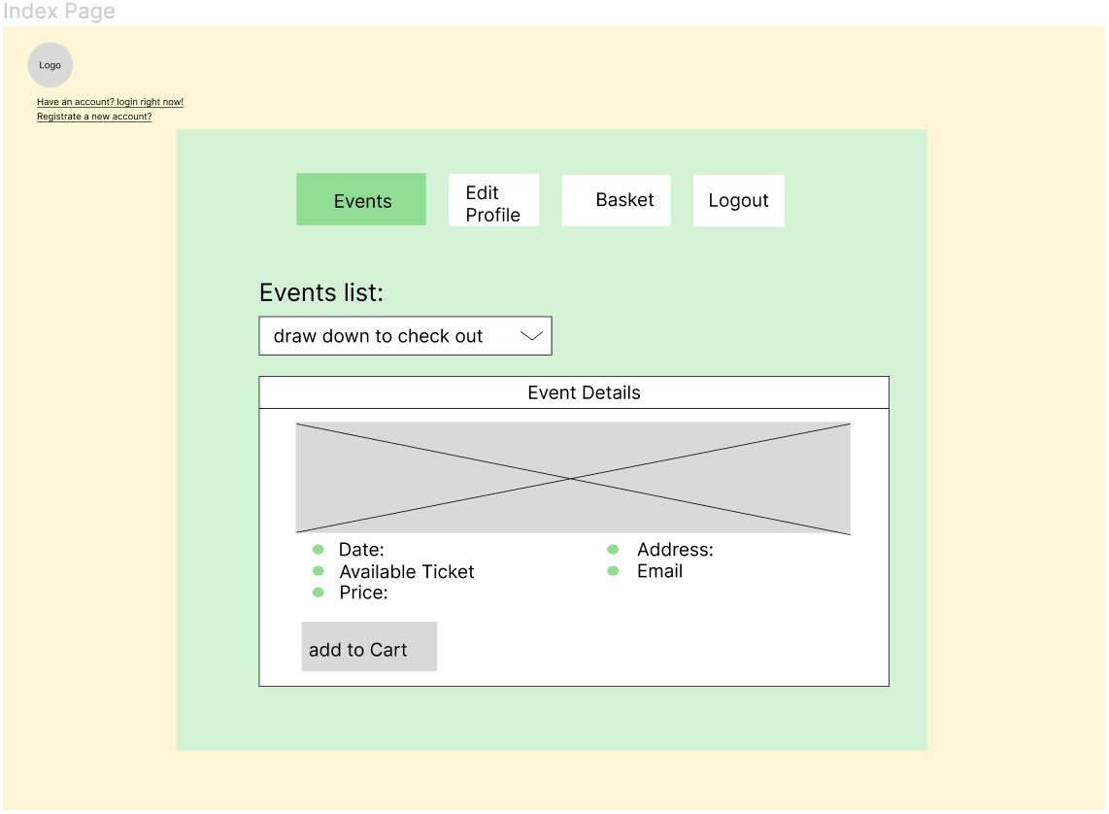

On the homepage of the participant, the user has several main functions. First, to view the basic information of a specific event such as location, price, etc. also, to edit the selected event(s) and the amount of tickets in the basket, Second. They can update their personal profile, such as email and phone number to keep in touch with relevant stakeholders such as megabook's service centre. In addition, to delete or add payment methods. Surely, users can log out of the page at any time.

### Host's Pages

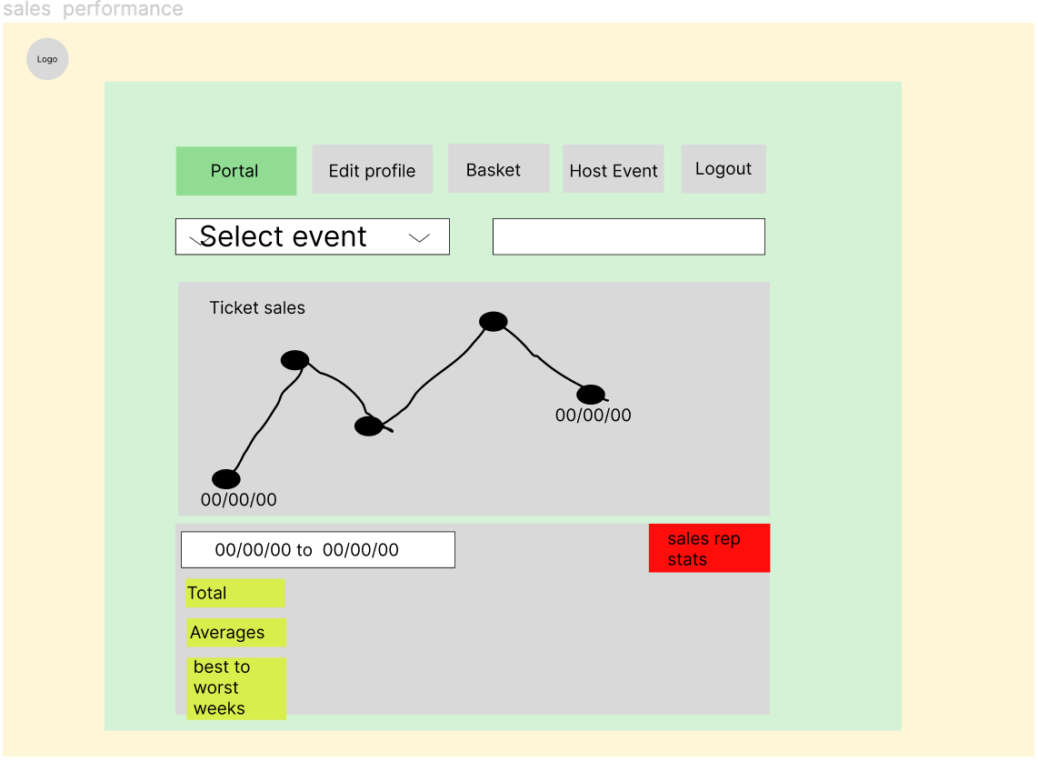

Every host can edit personal information like a participant, and can also check and analyse the sales history of a certain event to obtain better sales targets and even get an annual bonus from Megabook via improving the event.

Furthermore, as funds for platform maintenance and for commercial purposes, megabook will charge each participant and host a fixed platform service fee for each transaction.

## Implementation Information:

The product we have chosen to build is an event booking system for the web called 'Megabook'. Upon carefully considering the various aspects of the development, established product features and delivery time, the Waterfall Model has adapted to the software production process.

The requirements are gathered, validated, and verified to establish the project's scope. Furthermore, the MoSCoW methodology has been used to prioritise requirements in the order of Must have, Should have, Could have, and Would have. The web application framework used for the website is Flask. CSS (Cascading Style Sheets) and JavaScript have been used to present and interact with the website. The requirement goals have been kept in check during the implementation process to ensure a realistic outcome.

The Trello workspace (www.trello.com) has been used as the project management tool. The tasks have been allocated among the team and added to the Trello workspace. The Trello workspace has split into three lists for this project, which are To Do, Doing, and Done. The Kanban method used in the Trello workspace was an effective tool to optimise the workflow between the team members. It has allowed the team to share the work and set realistic goals. The team has also used the Trello workspace to communicate and share the finished works. The latest work progress of each team member is updated and monitored.

The prioritised requirements applied towards creating the wireframes in addition to the interfaces before stepping upon this project's implementation stage. These wireframes and interfaces provide a unique insight into the website the team aims to build. These wireframes and interfaces have been adapted to reflect and facilitate a truly user-friendly experience for the website.

As part of the design documents, the team has developed a Data Flow Diagram (DFD) to visualise and better understand the information flow through the system. In addition, the Data Flow Diagram will also enable the team to discover any potential problems and improve efficiency while implementing the website. After that, all the potential data will be exhibited and considered clearly.

The team will use GitHub (www.github.com) to facilitate version control and to enable efficient collaboration.

# Test Plan:

| Test ID | Test | Program Status | Input/Event | Expected Outcome | Actual Outcome | Result(Pass/Fail) |
| --- | --- | --- | --- | --- | --- | --- |
| 1 | server runs successfully | terminal | Press play button | Show a message that the server is running on a specific url in the terminal. Index web page opened(see the page designs) | Show a message that the server is running on "http://127.0.0.1:5000" in the terminal. Index web page opened. The logo and two navigation links are presented. | Pass |
| 2 | login label redirection | Index page | Press the login label | A login page with all designs opened. Path of the url changed from '/' to '/login'. | Without any response | Fail |
| 3 | Sign up label redirection | Index page | Press the sign up label | A sign up page with all designs opened. Path of the url changed from '/' to '/signup. | A sign up page with all designs opened. Path of the url changed from '/' to '/signup. | Pass |
| 4 | Logo picture redirection | Index page | Press the logo picture | An index page with designs opened. path of the url changed from'/' to '/'. | An index page with designs opened. Showing the same url. | Pass |
| 5 | Login button | login page | Press the login button | Case login successful: path of the url changed from '/login' to /'participant'. A home page with designs is presented. Case login failed: show a message 'email or password wrong.' | Url didn't change. And the page did not redirect to a home page with its designs. | Fail |
| 6 | 'Find out email/password' label redirection | login page | Prese the label | Path of the url changed from '/login' to '/find_info'. Find information page opened with related designs | Path of the url changed from '/login' to '/find_info'. Find information page opened with related designs | Pass |
| 7 | Sign up label redirection | login page | Press the sign up label | Path of the url changed from '/login' to '/signup'. Sign up page opened with designs | Path of the url changed from '/login' to '/signup'. Sign up page opened with designs | Pass |
| 8 | Send link button | Find information page | Press 'send a link' button | A message shows that input correct email when the email could be found in the database or is not an email formal. Or a message shows that the link is sent to the email. | Nothing happened | Fail |
| 9 | login button redirection | Find information page | Press 'back to login' | Path of url redirected to '/login'. login page with designs appears. | Path of url redirected to '/login'. login page with designs appears. | Pass |
| 10 | Sign up label redirection | login page | Press sign up label | Path of the url changed from '/login' to '/signup'. Sign up page opened with designs | Path of the url changed from '/login' to '/signup'. Sign up page opened with designs | Pass |
| 11 | Email validation | Sign up page | Sign up form submit with invalid email | Showing a message "invalid email address, try again" | No any message pop up | Fail |
| 12 | Password validation | Sign up page | Sign up form submit with different password | Showing a message "password is not the same, please double check!". And the password input displayed as dots | No messages pop up. Password input box shows every string input. | Fail |
| Refactor round 1 | | | | | | |
| 8 | Send link button | Find information page | Press 'send a link' button | A message shows that input correct email when the email could be found in the database or is not an email formal. Or a message shows that the link is sent to the email. | Nothing changed on the page. A debug message shows that Uncaught Type Error | Fail |
| 11 | Email validation | Sign up page | Sign up form submit with invalid email | Showing a message "invalid email address, try again" | No any message pop up | Fail |
| 12 | Password validation | Sign up page | Sign up form submit with different password | Showing a message "password is not the same, please double check!". And the password input displayed as dots | Typing in password input box with dots covered, message don't show up | Fail |
| 2 | login label redirection | Index page | Press the login label | A login page with all designs opened. Path of the url changed from '/' to '/login'. | A login page with all designs opened. Path of the url changed from '/' to '/login'. | Pass |
| 5 | Login button | login page | Press the login button | Case login successful: path of the url changed from '/login' to /'participant'. A home page with designs is presented. Case login failed: show a message 'email or password wrong.' | Path of the url changed from '/login' to /'participant' when using an account for testing from database.A home page with designs is presented. when inputting the email and password which are not matching from the database. A message showed 'Email/Password wrong!' | Pass |

# 4,

# MoSCoW Prioritisation chart

# 

# 

# Must have

# 

# take bookings

# set/change price

# Take a booking fee from customers

# cancel events and return money

# Edit details of event

# Can Log in/Log out of the system and reset the login password

# See price

# Select num of tickets

# see which club

# date

# details of event

# share event

# sign up

# payment system

# 

# 

# Should have

# See total rev of the event

# promotion

# generate reports (events reports, revenue reports, cancellation reports)

# Share link to put event up on social media

# Location based

# 

# 

# Could have

# make discount codes

# manage event staff

# QR codes and brand picture to link events from flyers

# Email collection to promote

# see age

# see who is new/returning

# Total confirmed bookings for events /compare between dates

# See amount of links shared

# See customers’’ feedback(via comment of social media, useful to improve qlty of service

# Keep track of amount of tickets reps are selling (individual code assign to each rep)

# See individual sales

# Allow people to sign up and become a rep

# Keep track of sales between time periods use graph to represent data

# See what other events attendees are booking to gather data

# Each reps’s sales records(amount of tickets, because sales bonus might be considered)

# see links to other similar events ie #disco

# Won’t have

# Develop a mobile application for the website

# Make a database of user behaviour for future use

# Live booking status for the manager

# Registered event users could see if their friends are attending by sharing social media platform information

# Accepting more payment methods (crypto currency)

# 5, Risk assessment

# 

| Risk | Result of occurrence | Impact | Likelihood | Risk factor | Mitigation to reduce likelihood or impact |
| --- | --- | --- | --- | --- | --- |
| Lack of time | Can’t finish the project | 10 | 6 | 60 | Prioritising the requirements according the MoSCow chart |
| Unforeseen requirements that must need to accommodate | Unable to complete the requirements and submit the project | 10 | 6 | 60 | Make sure the detailed research and requirements are carried out and recorded in the MoSCoW chart. |
| Unable to fulfil certain requirements | The app doesn’t have all the features wanted by the stake holder | 7 | 10 | 70 | Identify and understand the primary stakeholders to prioritise the features important for the app |
| Spending more time than assigned on one part of the project | Less time spent on the required part of the project | 7 | 7 | 49 | Making sure the Gantt chart is followed |
| Illness among the team members | Delays in project delivery | 9 | 5 | 45 | The ability for team members to work from home |
| Security of the booking system (login credentials, payment details, customer personal information) | Loss of money and reputation. Legal issues related to data protection laws | 10 | 5 | 50 | Installation of security systems to protect the online assets and data centres. And assign a team to prepare for the likelihood of a cyber attack. |

# 

# 6,Data Flow Diagram

# 

# 

# 

# 

# 7, Github

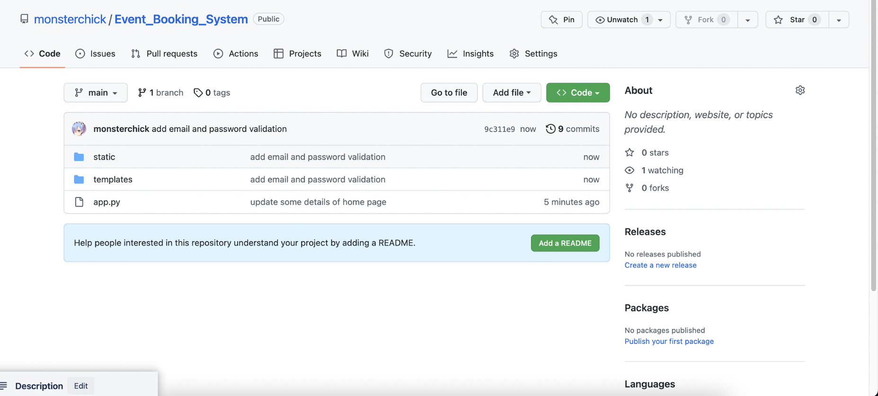

8. Gantt Chart

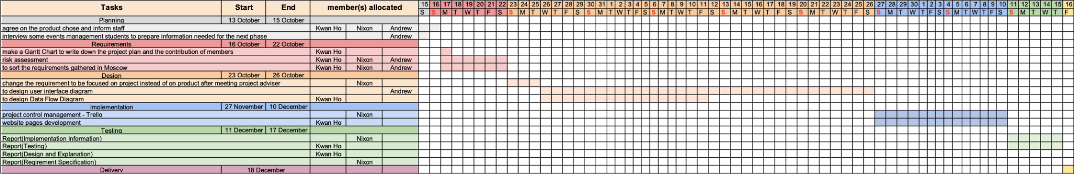

# Reference:

*CarinaPaineaEnvelope, E.M. (2007) Internet users' perceptions of 'privacy concerns' and 'privacy actions', International Journal of Human-Computer Studies. Available at: https://www.sciencedirect.com/science/article/pii/S107158190700002X (Accessed: December 16, 2022).*